* **[www.Orion-XT10.com - Close Encounters of the XT10 Kind](http://www.orion-xt10.com/home.html" \o "Home Page)**
* **[Orion Skyquest XT10 Intelliscope Reviews](http://www.orion-xt10.com/orion-xt10.html" \o "The XT10 - Orion's 10inch Newtonian Reflector)**
* **[Assembly of the Orion XT10i Dobsonian](http://www.orion-xt10.com/xt10-assembly.html" \o "Constructing the Orion XT10 OTA)**
* **[Collimation Techniques and Resources](http://www.orion-xt10.com/newtonian-collimation.html" \o "Collimation - Techniques and resources)**
* **[Orion XT10 Astrophotography](http://www.orion-xt10.com/xt10-astrophotography.html" \o "Astrophotography)**
* **[Telescope Equipment, binoculars, eyepieces and setup.](http://www.orion-xt10.com/telescope-accessories.html" \o "Telescope Equipment and Accessories)**
* **[Bio](http://www.orion-xt10.com/bio.html" \o "Bio)**
* **[Contact](http://www.orion-xt10.com/contact.html" \o "Contact)**
* **[XT10 Modifications](http://www.orion-xt10.com/mods.html" \o "XT10 Mods and Improvements)**
* **[Astronomy Links and Resources](http://www.orion-xt10.com/links.html" \o "Astronomy Resources)**

**Orion Dual Speed Low-Profile Crayford Focuser and Accufocus Variable Speed Motorised Autofocuser Review**

**Review and Fitting of the Orion Dual Speed Low-Profile Crayford Focuser and AccuFocus Variable Speed Motorised Autofocuser**

One of the problems when fine-focusing highly magnified stellar objects is that the slightest movement of the telescope can make the view shake and become blurred, but of course you need to touch the wheels of the focuser in order to focus it, yet the view needs to be still to judge whether the adjustment just made has improved the focusing. Also while the standard Crayford focuser is fairly good, its adjustment can be a bit coarse.

I decided to purchase both the new style **Dual Speed Low-Profile Crayford Focuser**for my **Orion XT10i**, and the **Accufocus Motorised variable speed autofocuser**.

This article reviews both of these units, and shows the fitting procedure. I also show how the **Accufocus** unit can be fitted to the original XT10i standard Crayford focuser.

**Please be patient - Lots of photographs loading.......**

The picture below shows the new **Dual Speed Low-Profile Crayford Focuser**installed, plus the **Accufocus**motor and its **Control Pad**mounted on the dobsonian base.

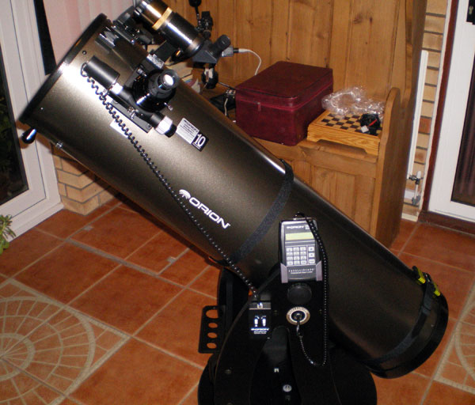

The main benefits provided by these two new units are:-

**Dual Speed Low-Profile Focuser:**

* High quality machined focuser with dual-speed (manual) focusing via three knurled control wheels
* Roller-bearing design eliminates image shift and includes 11:1 fine focus control
* Accomodates 2 inch and 1.25 inch eyepieces
* Low-profile design intended for Astrophotography purposes
* Fits Orion XT8 and XT10 telescopes
* Anodized-aluminum construction easily supports cameras or heavy 2" eyepieces
* View details on the Orion website: [Orion Dual Speed Low-Profile Focuser](http://www.telescope.com/control/product/~category_id=focusers/~pcategory=accessories/~product_id=08881" \t "_blank)

**Accufocus Motorised Focuser:**

* Precise, smooth, vibration-free focusing
* Variable speed motor (quiet coarse/fast to very slow/fine focusing is possible)
* Supplied with brackets for standard Crayford focuser, and older rack-and-pinion focuser, **but low-profile Crayford focuser requires additional bracket to be purchased seperately**
* 9v battery included
* Control panel and long coiled cable
* View details on the Orion website: [AccuFocus Motorised Focuser](http://www.telescope.com/control/product/~category_id=focusers/~pcategory=accessories/~product_id=24765" \t "_blank)
* PDF of scanned installation manual: [Orion AccuFocus Installation Manual](http://www.orion-xt10.com/OrionAccuFocusManual.pdf)

**Standard Crayford Focuser**

I have already provided a [review of the standard crayford focuser supplied with the Orion XT10i](http://www.orion-xt10.com/xt10-focuser.html), but now a year on I can add some further thoughts on the unit.

[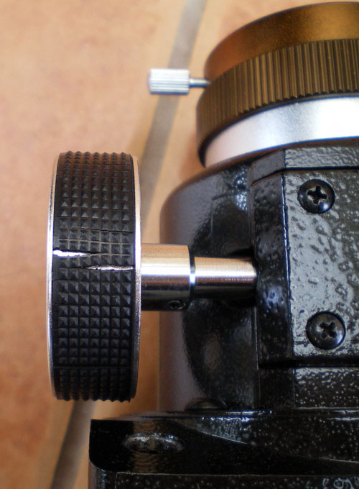](http://www.orion-xt10.com/images/LPC-Old-Perished.jpg)The basic focuser has performed fairly well, and its large focusing wheels do provide fairly smooth focusing operation. To my surprise however the black rubber knurling on the wheels has perished and split already (just 1 year old!). This could be due to the fact my telescope lives in our conservatory where daytime temperatures can be high in the summer, and very cold in the winter. I keep it here because at night it is much cooler and therefore the temperature of the primary mirror is nearer to the outside temperature which means shorter cooldown times. So perhaps these extremes have caused the rubber to harden and age quite quickly.

I have had to use some epoxy resin glue to fix the rubber material back onto the wheels to prevent it falling off.

As explained at the head of this page, one of the main factors in deciding to replace the standard focuser was to provide finer and vibration-free focusing control. The **AccuFocus** motorised unit provides very fine stepper motor control, and this can be installed as an upgrade to the standard focuser as will be shown later in this review. It also comes supplied with the necessary bracket to allow mounting the Accufocus to the older Orion rack-and-pinion focusers.

The **AccuFocus**control unit allows easy adjustment without even touching the main telescope, and this means a totally steady view through the eyepiece so you can concentrate on the sharpness of focus.

**Opening the Low-Profile Focuser and AccuFocus Motor boxes**

[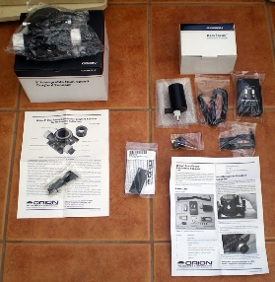](http://www.orion-xt10.com/images/LPC-Unpack3.jpg)The contents of the two boxes are shown in this photo (as with all photos on this page click to enlarge, then hit Back key when finished viewing).

Remember these are seperately ordered items. Both come with well written installation instructions, and individual bags containing allen key tools, nuts/bolts, cables, battery and brackets.

[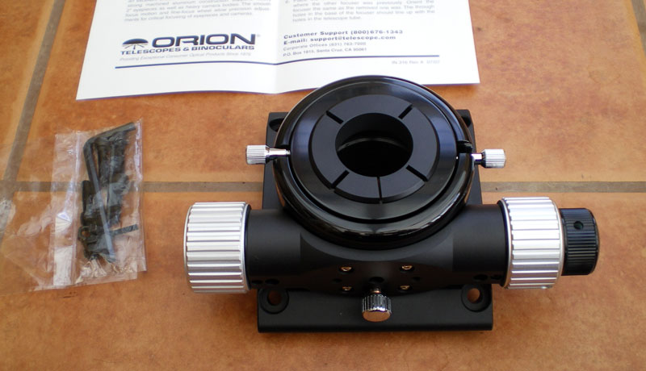](http://www.orion-xt10.com/images/LPC-Unpack1.jpg) [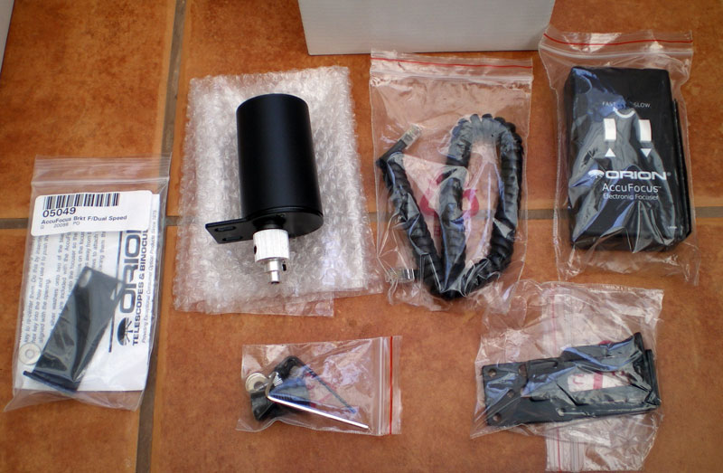](http://www.orion-xt10.com/images/LPC-Unpack2.jpg)

**Examining the Low-Profile Crayford Focuser**

First let's take a moment to view the focuser in closer detail.

As you can see it is a fine instrument, beautifully finished anodised aluminium and glossy black finish with the Orion logo, chrome screws and hex-bolts, anodised collett 1.25" eyepiece adapter/holder, aluminium adjusting wheels, and black knurled fine adjustment wheel with an 11:1 ratio (one turn of the main focus wheel equals eleven turns of the fine focus wheel), an extension tube thumbwheel, and eyepiece adapter-tightening thumbwheel.

The right-hand photo shows the front-side (the side that faces you when viewing through the eyepiece, so that the fine focus adjustment is operated by the right hand). On this side you can see the chrome-finished knurled focus-lock wheel for locking the drawtube in position, and just above it the centre-hole with hex-head adjustment for adjusting the tension of the crayford mechanism.

Also supplied but not shown in any of the photos on this page is a white 1.25" polythene dust cap which inserts into the eyepiece holder when in storage.

[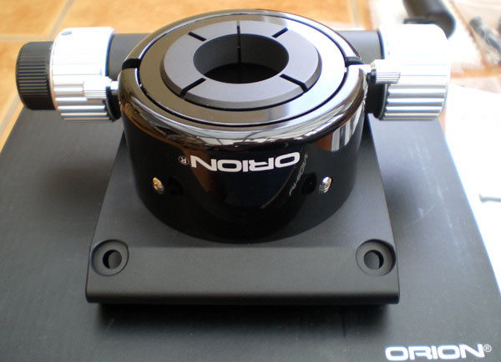](http://www.orion-xt10.com/images/LPC-Unpack5.jpg) [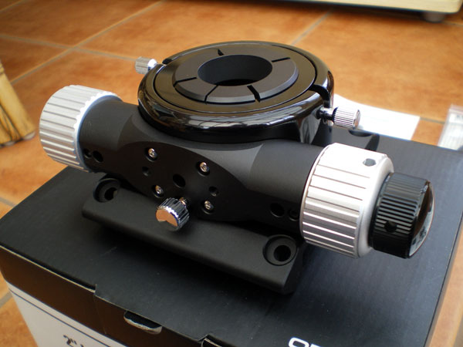](http://www.orion-xt10.com/images/LPC-Unpack4.jpg)

**Taking a closer look**

The next photographs show four closer views of the focuser, and the surprising distance it can extend outwards!

Now you can see the 2" eyepiece drawtube has been fully extended, and the 1.25" eyepiece collett has been removed, revealing the collett tightening clip (copper clip inside the top).

Extending of the main drawtube is done by undoing the lower tube thumbwheel, then pulling the tube upwards, then re-tightening in the required position. In addition to the nominal focus travel of 24mm the extendable drawtube adds a further 44mm of focus travel yielding a total focus range of 68mm. This is a welcome feature when switching between an eyepiece and a camera, as no external extension tubes are required.

When the thunbwheel is undone the extension tube has considerable slop (something noted in the personal product reviews by one purchaser on the main Orion website). I agree that there is a lot of sideways slop movement when this is undone, and may cause concerns regarding collimation of the focuser, but upon re-tightening the thumbwheel it seems to reposition the tube accurately provided it is done up sufficiently tightly.

Note how the bottom section is extended outwards - this is the focusing adjustment travel.

The minimum focus height is quoted as 43mm. The maximum focus travel (bottom section) is 24mm, and 68mm with the 2" drawtube fully extended. This is good news for some wide-angle 2" eyepieces (such as my 38mm SWA) which can be very close to the endstop focusing range (sometimes I would need to pull the 38mm slightly out of the standard focuser and re-tighten it so as to achieve a full focusing range). This new Crayford focuser provides just a little bit extra extension compared to the original Crayford which overcomes this problem.

[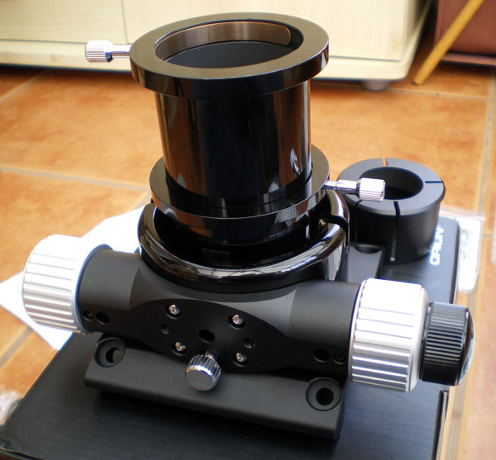](http://www.orion-xt10.com/images/LPC-Unpack9.jpg) [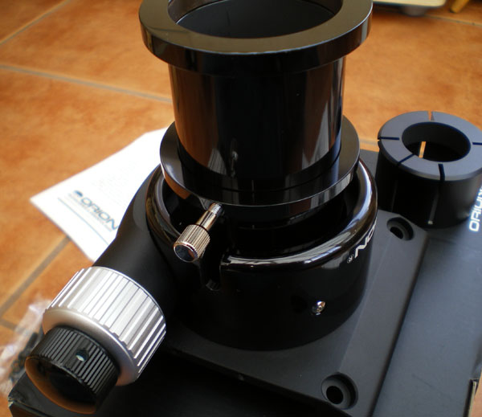](http://www.orion-xt10.com/images/LPC-Unpack8.jpg)

[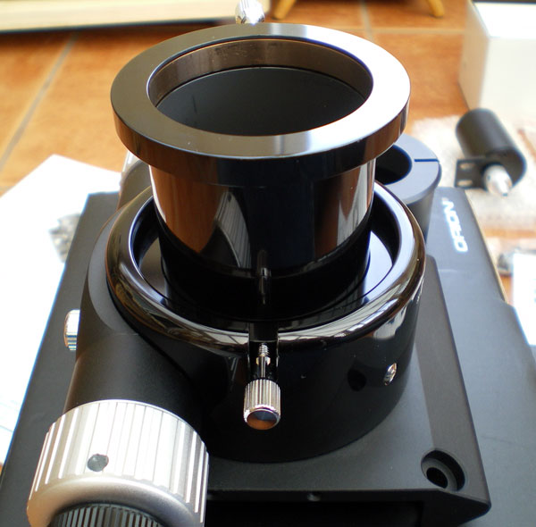](http://www.orion-xt10.com/images/LPC-Unpack7.jpg) [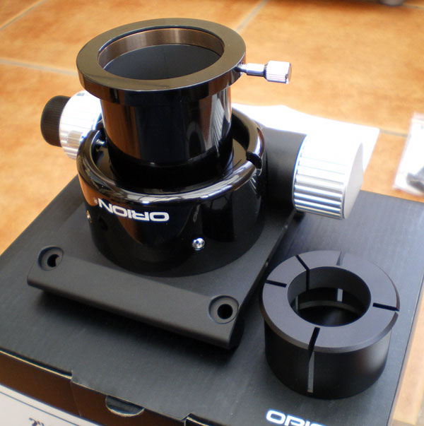](http://www.orion-xt10.com/images/LPC-Unpack6.jpg)

**Two-inch Compression Ring**

The next nice feature of the focuser is the **compression ring**that facilitates a firm grip on either; 2 inch eyepieces inserted into the focuser, or the **1.25" eyepiece adapter**for holding smaller eyepieces, webcams, etc.

This **compression ring**provides even pressure around a greater portion of an eyepiece or the adapter, instead of just a single point of contact by a thumbscrew (the old focusers' thumbscrew has resulted in tiny dent-points in the circumference of my eyepieces). The ring helps achieve less axial movement of the inserted item, and therefore better central collimation. This is a simple, yet worthwhile improvement over the standard focuser. *[ I have overtightened the thumbscrew deliberately in the pictures to demonstrate its operation, it would not normally be tightened this much.]*

My 2" 38mm SWA eyepiece when inserted loosely has some slight play in the drawtube. I don't think the amount of slop is too bad. It makes for easy insertion and removal of the eyepiece, and when the eyepiece is inserted fully flat against the drawtube face, and the compression ring thumbscrew is tightened properly there is no movement of the eyepiece.

[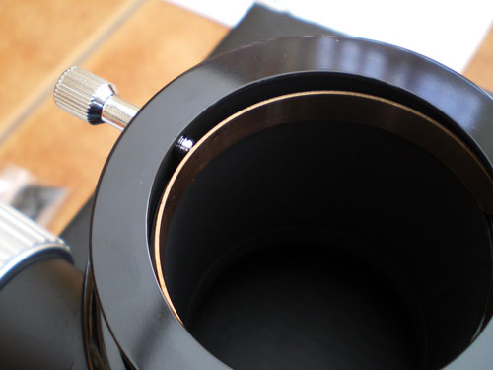](http://www.orion-xt10.com/images/LPC-Collett.jpg) [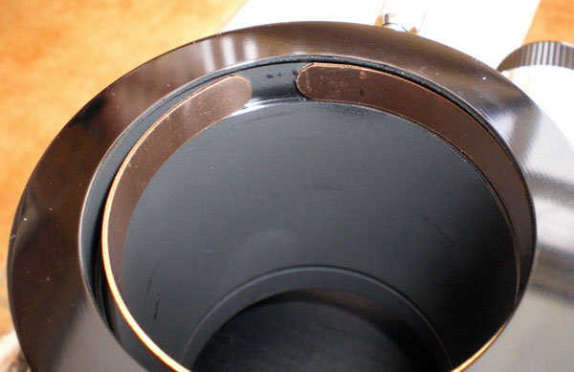](http://www.orion-xt10.com/images/LPC-Collett2.jpg)

The next two photos demonstrate the **1.25" eyepiece adapter**inserted into the focuser, and how the **compression ring** tightens the adapter onto the eyepiece. Note how the gap in the adapter has closed up in the right-hand photo. It requires considerable pressure to squeeze the ring tight around an eyepiece, and perhaps the thumbwheel could have been made slightly larger so its more comfortable on your fingers when tightening.

[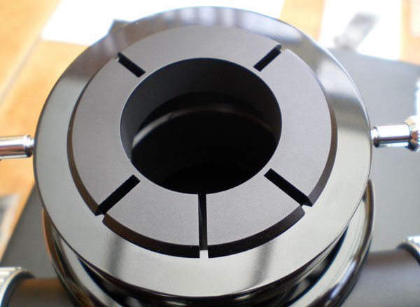](http://www.orion-xt10.com/images/LPC-Adapter-Loose.jpg) [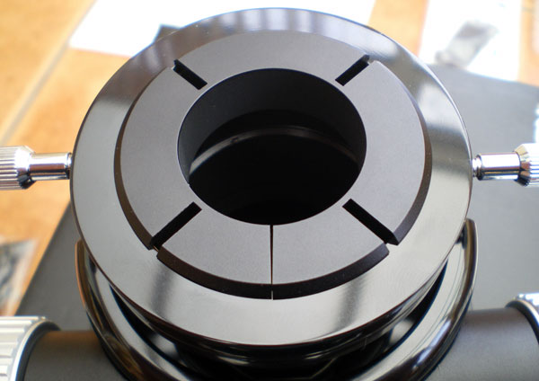](http://www.orion-xt10.com/images/LPC-Adapter-Tight.jpg)

The machined tolerance of the eyepiece adaptor is very fine! It must be pretty much exactly 1.25 inches inner diameter as the grip it has makes it quite difficult to insert eyepieces. While this has the benefit of holding eyepieces securely without requiring any tightening of the compression ring thumbwheel, it unfortunately makes it difficult to easily remove an eyepiece from the adaptor itself.

You have to undo the **compression ring**thumbwheel and remove the entire eyepiece adapter so that you can use both hands to pull the eyepiece out of the adapter! This is an annoyance when you have sighted-up a planet and want to insert a higher magnification eyepiece - because obviously you want to minimise any kind of movement of the scope when changing eyepieces. I think what is frustrating about it, is that it's not easy to insert or remove eyepieces in the adapter. What's the point of having a gap in the adaptor to allow tightening to take up slack, if there is just no slack anyway!?  
  
Changing 1.25" eyepieces should be a one-handed 4 step process; 1) Undo compression ring, 2) remove eyepiece, 3) insert different eyepiece, 4) tighten compression ring.   
  
Now it's a 7 step two-handed process; 1) Undo compression ring, 2) remove adapter+EP, 3) use both hands to pull EP out of adapter, 4) store EP, get new EP, while still holding onto adapter, 5) put new EP into adapter using both hands, 6) insert adapter+EP back into focuser, 7) tighten compression ring. You end up not having enough hands, and I have accidentally dropped the adapter on the patio (luckily no EP) - it bounces well, several times, with a sharp metallic ring!  
  
I don't know that I personally can do anything about this. I suspect if I tried to stretch the diameter of the adapter open it would crack in half. And I don't have access to any kind of lathe to increase the inner diameter. So unless Orion can do something about this I have to live with it. *[Please see the Conclusion later for an update from Orion on this]*.

[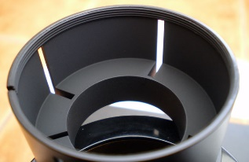](http://www.orion-xt10.com/images/LPC-Adapter-Thread.jpg)A nice touch on the underside of the adapter on the 2 inch diameter section is the threading to accept 2 inch filters and the like.

**Even closer round trip**

Just a few more photos to show some of the finer details of the focuser.

The left hand photo shows the various holes enabling access to the hex nuts which hold the focus adjuster wheels on, and the chrome hex screws and centre hex-screw hold and adjust the actual Crayford mechanism to the focuser body, plus some mounting holes which are used to mount the Accufocus motorised focuser bracket.

The right hand photo just shows the finish of the control knobs. **From the factory the action of these controls are very nice and smooth**. No roughness, stiffness or binding commonly associated with "Chinese grease". The fine adjustment knob requires very little effort to turn.

[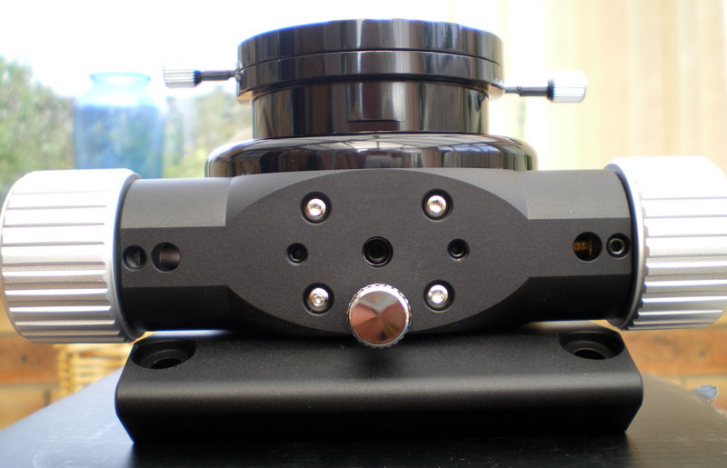](http://www.orion-xt10.com/images/LPC-Unpack10.jpg) [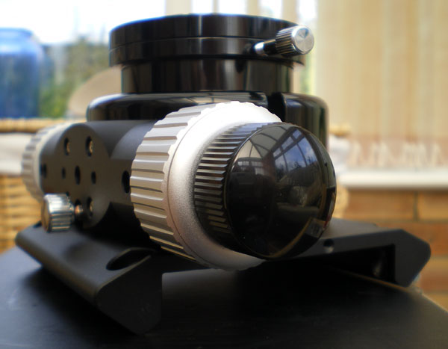](http://www.orion-xt10.com/images/LPC-Unpack11.jpg)

For some reason there are two small threaded holes in the base of the unit (below left-hand photo). There is no indication in the instructions as to what these are for. Presumably they would hold some other kind of mounting bracket (or dust covers - see comments further below)?

Below right picture shows underside of the focuser, which you will note is finished in anodised black finish on the exterior of the drawtube, and anodised matt-black on the interior to minimise light reflections.

[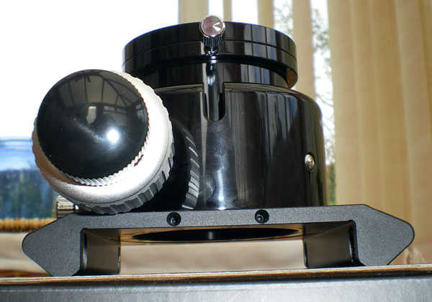](http://www.orion-xt10.com/images/LPC-Unpack12.jpg) [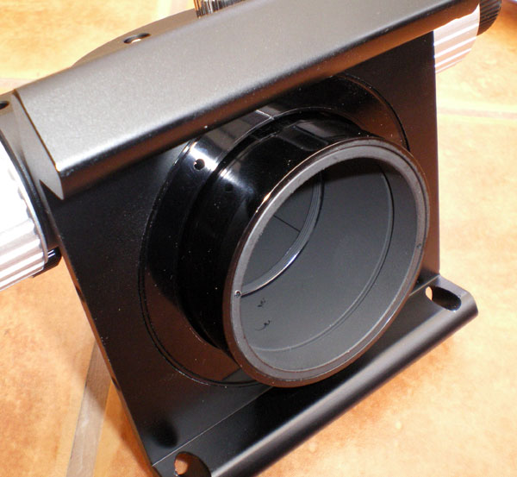](http://www.orion-xt10.com/images/LPC-Underside.jpg)

**Removing the old focuser**

Four nuts and bolts hold the focuser in position on the telescope tube. Cross-head screwdriver and small spanner or socket-set are required to undo them.

IMPORTANT: As mentioned elsewhere in my web pages, be sure to perform this work with the top of the telescope tube pointing downwards/horizontal to avoid any accidents of dropping things down the tube onto the primary mirror.

[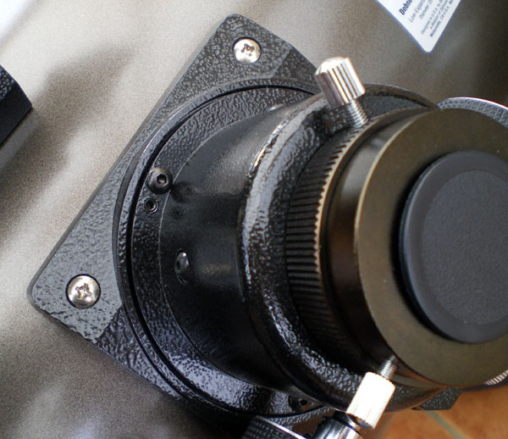](http://www.orion-xt10.com/images/LPC-Unscrew-old.jpg) [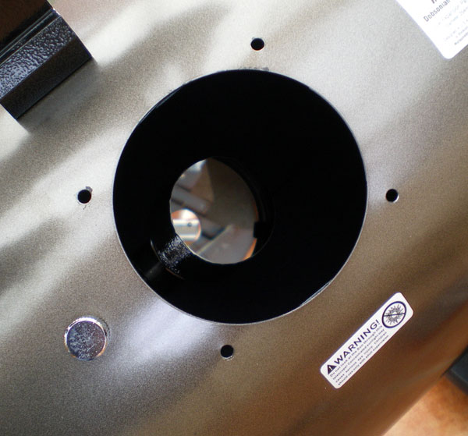](http://www.orion-xt10.com/images/LPC-Old-removed.jpg)

**Side-by-Side Comparison**

Now that we have removed the old focuser we can do a side-by-side comparison of the two focusers. I have done this chiefly so that you can see the height of each when their drawtubes are fully extended.

For interest I also weighed the two units. The original crayford is 740g, whereas the newer focuser is 180g heavier at 920g.

[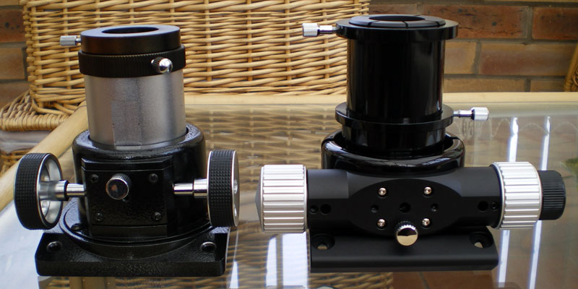](http://www.orion-xt10.com/images/LPC-Side-by-Side-Front.jpg)

[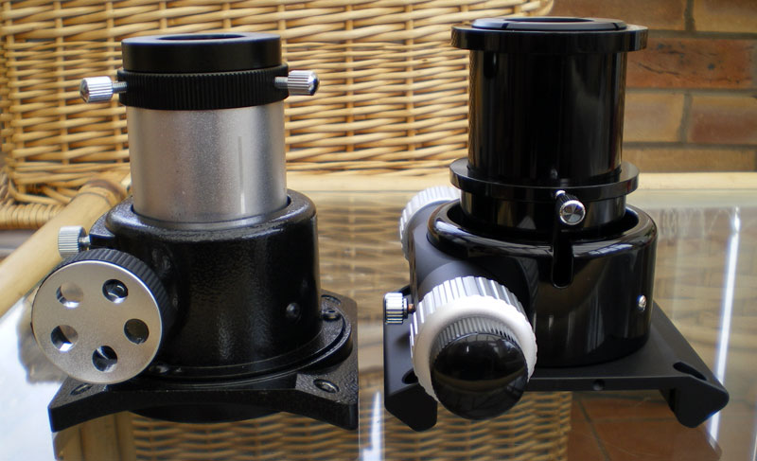](http://www.orion-xt10.com/images/LPC-Side-by-Side-RH.jpg)

[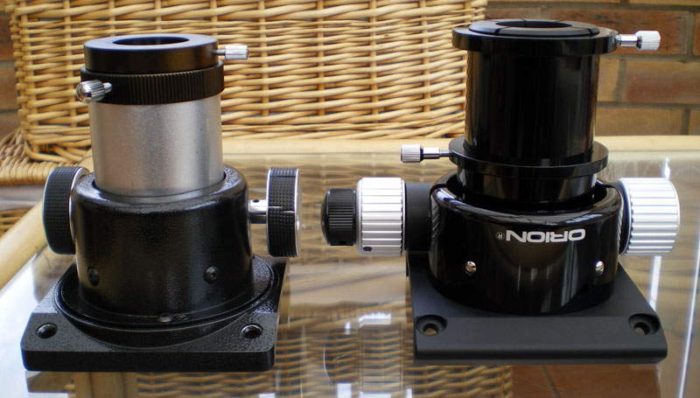](http://www.orion-xt10.com/images/LPC-Side-by-Side-Back.jpg)

[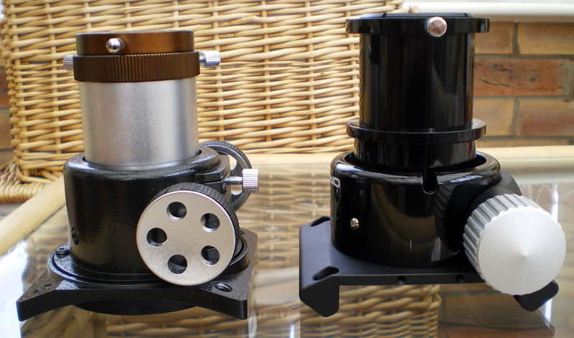](http://www.orion-xt10.com/images/LPC-Side-by-Side-LH.jpg)

**Fitting the Low-Profile Crayford Focuser**

The new focuser has a mounting plate designed to be a direct replacement for the original focuser, and fitting it is a simple case of using the new hex-head bolts and nuts supplied with kit.

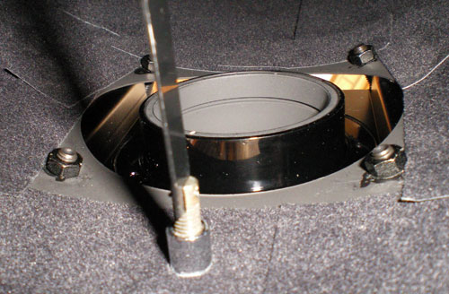

The only thing that concerned me with fitting the new focuser is that there is a massive gap (about 1 inch) around the cut-out in the telescope tube, and between the mounting plate underside and the tube surface, as can be seen both in the pictures above and below. There is plenty of potential for dust to go through this gap when the telescope is in storage, so I felt it was wise to try and close the gap somehow.

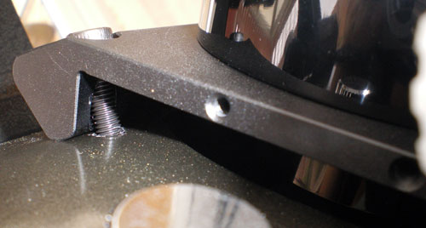

I had some acoustic sound-proofing foam to hand (pity it wasn't black!) which I cut to shape using scissors, and then removed the focuser and placed the foam between the focuser and the tube, and refitted the focuser. I used some tweezers to help pull the foam into the right position to ensure a good fit all round, and so that it looked neat from the outside. Internally I also made sure the foam was clear of the bottom of the drawtube so that it would not interfere with its movement in or out, nor obscure the optical path.

This is an area I think Orion should have provided a properly cut foam packer similar to my solution. Alternatively I did wonder if the threaded holes in the ends of the baseplate are intended to allow some kind of proper end fascias to be mounted onto it to cover the gap? As I mentioned earlier in this review there is no mention of the purpose of these threaded holes.

[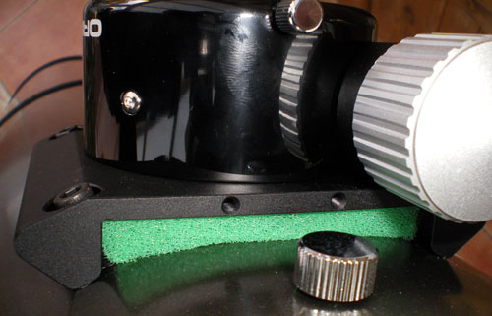](http://www.orion-xt10.com/images/LPC-Foam-1.jpg) [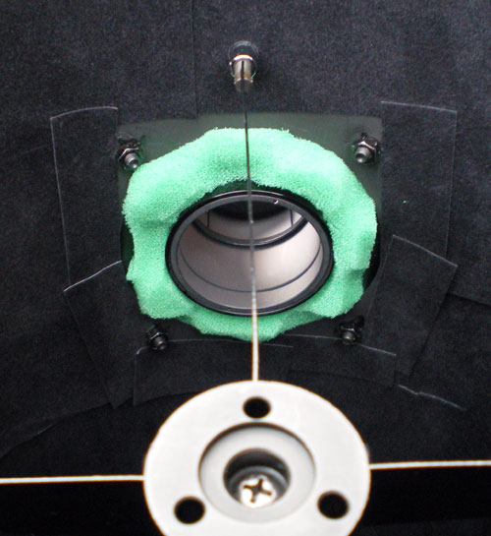](http://www.orion-xt10.com/images/LPC-Foam-3.jpg)

So now we have the new focuser fitted. And it looks mighty good on the XT10.

Damn, I've put a greasy fingerprint on that lovely polished surface!

**Fitting the AccuFocus Motorised Focuser**

The next step was to fit the additional **AccuFocus** unit.

First we remove the left-hand side large aluminium control knob from the focuser.

[](http://www.orion-xt10.com/images/LPC-Unpack9.jpg)[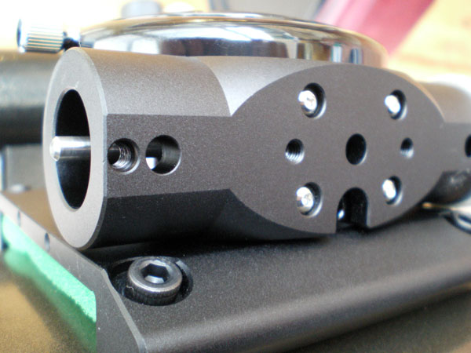](http://www.orion-xt10.com/images/LPC-AF-NewFit-1.jpg)[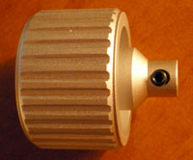](http://www.orion-xt10.com/images/LH-Foc-Knob.jpg)

This is simply a case of rotating the control knob to reveal its hex key retaining grub screw through the 2nd access hole from the left (see right pic) on the crayford faceplate, undo it, then slide the knob off the shaft. The shaft has a diameter of about 4mm.

[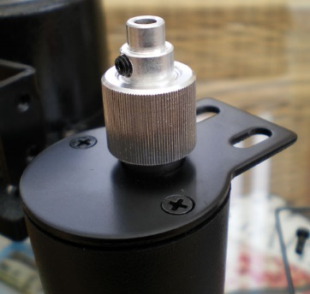](http://www.orion-xt10.com/images/LPC-AF-Motor2.jpg)[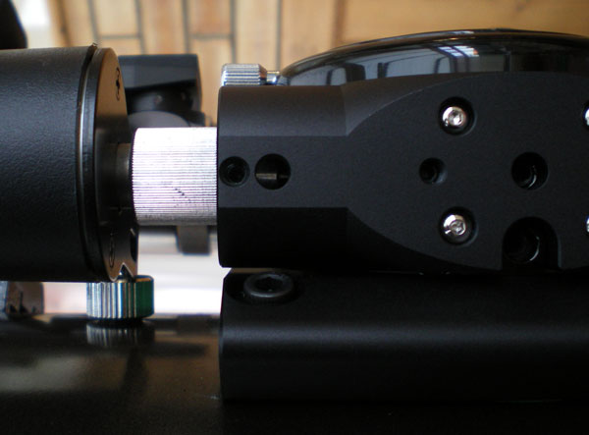](http://www.orion-xt10.com/images/LPC-AF-NewFit-2.jpg)With the control knob removed we can offer up the motor unit onto the focuser shaft, and do up its hex-key grub screw, through the 1st hole from the left.

*[Note: The stepped motor spindle/shaft (left pic) in fact has 2 grub screws on its shaft, each on opposite sides, and out of line with each other. The one furthest from the motor shown in the left hand picture is what tightens up to secure on the 4mm diameter focuser spindle . See the larger photo below which shows the other of the two grub screws which you should not need to undo. If you do undo it, this allows the smaller end of the aluminium spindle (left pic) to unscrew out of the larger knurled part.]*

Unfortunately there is not a flat keying feature on the 4mm shaft shaft to prevent slippage, so the grub screw needs to be done up very tightly.Careful judgement is required of the torque necessary so that its tight enough without breaking the screw or the hex-key while doing it up! You definitely do not want to strip the thread.

The reason I am making the point of doing it up nice and tight, is that you don't want to discover any loss of grip later on once the motor bracket is covering up the access hole as that prevents you tightening it!

I don't understand why there is not a flat keying section on the shaft. The standard Crayford focuser has keying sections, so I really don't know why this was omitted on the newer focuser.

With the motor spindle done up on the focuser shaft it now supports it own weight temporarily, ready for the mounting bracket to be attached.

The left hand pair of the four chromed hex-head bolts are undone and removed as in the photo below (compare to above right photo). Note that within these holes are small rubber washers, and care is required that they do not get knocked out of position when attaching the bracket to the crayford faceplate.

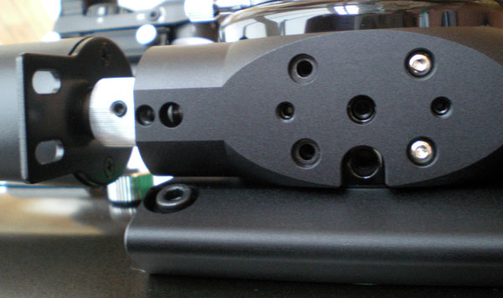

Using the various screws, washers and nuts supplied with the kit, the bracket is attached to the motor body, and then everything tightened up while simultaneously checking for good alignment of the motor with the shaft and focuser body. See what I mean about the bracket now covering the holes?

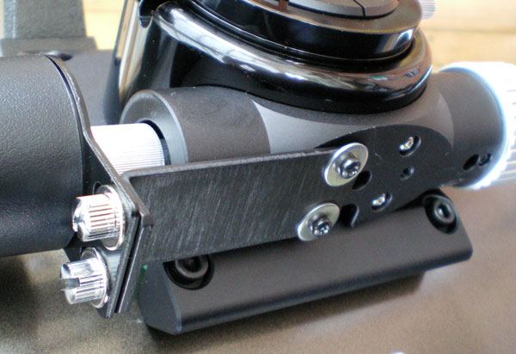

There we have it. The fully assembled Crayford focuser plus AccuFocus motor. Looks pretty cool doesn't it. You wait till you start using it, and see what a difference it makes. Smooth pin sharp, vibration free focusing - Nice!

[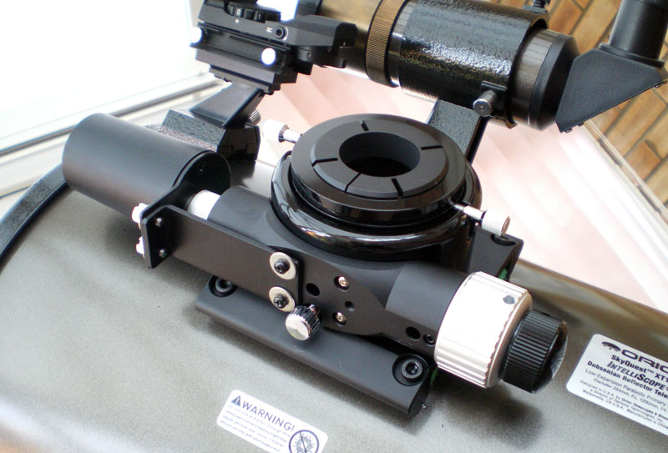](http://www.orion-xt10.com/images/LPC-AF-NewFit-5.jpg)

**The AccuFocus Control Unit**

[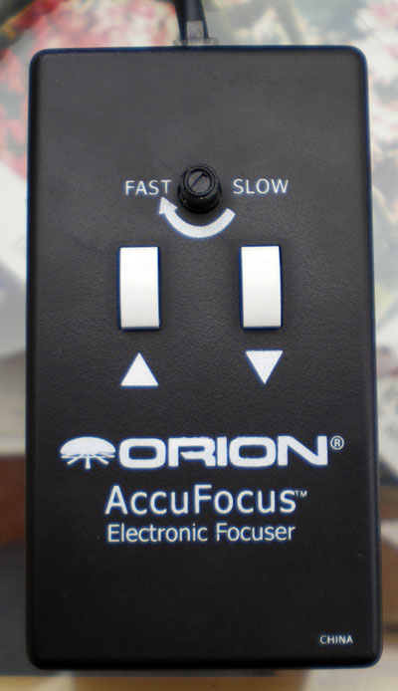](http://www.orion-xt10.com/images/LPC-AF-ControlPad.jpg)[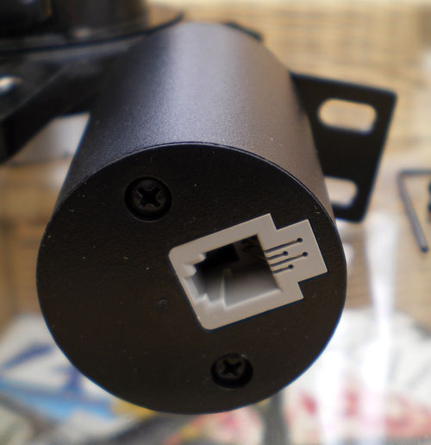](http://www.orion-xt10.com/images/LPC-AF-Motor1.jpg)All that remains is to insert the supplied PP3 9v battery into the **AccuFocus Control Unit**, and plug the curly cable into the top of the **Control Unit** and the rear of the **Motor Unit**.

The controls on the pad are fairly self-explanatory, but the only thing I would like to have seen was a larger knob on the rotary motor speed control, because on cold nights when you are wearing gloves, this is a bit on the small side to operate easily.

The Forward/Reverse buttons feel like they operate micro-switches under the hood. These have a good positive click when operated.

The **Control Unit** is supplied with a strip of velcro for attaching it in a convenient position to the dobsonian base. The only thing I found was that after a while the strip became unstuck from the back of the control unit, so had to be stuck back on more permanently with some epoxy resin.

Also the battery compartment is a very tight fit. You have to make sure the battery and cable are a particular way around before the back will clip back on nicely.

**Conclusion**

There were a couple of things that I did not consider (or know about) before I purchased both the **Low-Profile Focuser** and the **AccuFocus Motorised Autofocuser**.

Since the motor unit acts directly on the main shaft of the Crayford focuser, and it has a very high gearing ratio, this means that with the AccuFocus fitted it is now no longer possible to adjust the focuser manually using the control knobs. The high gearing makes it impossible to turn the knobs without causing damage to the motor gearing (there is a warning about not forcing the motor in the instructions).

This has a couple of different effects which are worth considering:-

1. Since neither the **coarse** or **fine**focus adjustment control knobs can be operated, it in effect means they are now redundant, and so that fine 11:1 adjustment you paid for is now not available! Well, of course we accept this because the **AccuFocus**motor now provides the fine adjustment, but it's just something to consider. You may do perfectly well by not buying the **Low-Profile Crayford**, and sticking with the **standard Crayford**, but with the benefit of fitting the **Accufocus**.
2. If the battery of the **AccuFocus** runs out of power, you cannot focus manually without completely removing the motor unit and bracket. This is not easy to do because you need to remove the bracket (four screws and washers), before you can get at the grub screw to loosen it to allow the motor spindle to be removed from the focuser shaft, and if the battery is completely dead you won't easily be able to rotate the spindle so the grub screw aligns with the access hole to undo it! Certainly not something to be doing in the dark!! **It's a minor point really, remedied by keeping a spare PP3 9v battery available.**
3. When changing eyepieces you get to know how far extended the focuser needs to be for each eyepiece, in or out. Also at the end of the night when packing away you might want to fully retract the focuser drawtube. The extension tube is easy - just undo the thumbscrew and let it drop back down. However the focuser travel can be pulled out or pushed back in by hand, and how easy this is depends on the tension adjustment of the Crayford mechanism which allows some slippage. In other words, although the static motor is preventing the control knobsfrom being turned, you can quickly push the focuser drawtube in or out by hand roughly to the position required by a particular eyepiece so its nearer its usual focusing position ready for fine adjustment by the motor, or can push the drawtube in fully when packing away, but you've already disconnected the control unit which supplies power to the motor.

Overall I'm quite pleased with the combination of these two units, and think they offer good value for money. The new Crayford looks and feels great. Very tight and accurate, and much better quality than the original crayford, and finished in matt-black to reduce reflections where it matters. The action of the Fine adjustment knob (when used without the AccuFocus motor unit) is feather light.

Certainly with regard to collimating in conjunction with my Baader Laser Collimator, it holds the laser far more snugly (no slop), and this helps achieve much better collimation of the scope.

When viewing and focusing critically, the ability to have hands-off motorised adjustment provides excellent focusing control. Using a fast speed to get near to focus, then turning the speed right down to about half or quarter speed, I can hit the Forward/Reverse buttons briefly to get very sharply focused images, much better than I was able to before the mod. Now all I have to battle with is "bad seeing"!!

When using the **AccuFocus Control Unit**I generally leave it dangling from the telescope; the curly cable is generally short enough to prevent it dropping onto the ground, and even though I sometimes attach the control unit velcro'd to the dobsonian base and operate it there, I often end up unintentionally pushing the dobsonian off-view when removing it from the velcro. Most of the time I prefer to have the controller in my lap while observing, or dangling where I can easily grab it without knocking the telescope off-view.

**Room for Improvement**

I think the things which could be improved by Orion on the two units are as follows:-

* The primary bugbear is the tightness of the 1.25" eyepiece adapter on eyepieces inserted into it. You really have to push/pull quite hard, and that adapter has some sharp edges on it which are not comfortable on bare hands. All the 1.25" accessories I own are tight in the adapter, but maybe other items would be a looser fit? While I agree that tight means accurate, it just needs to be a fraction looser, so that eyepieces can be inserted or removed easily, and any slack taken up by the compression ring thumbscrew.
* Larger thumbwheel to tighten the compression ring onto the eyepiece adapter collet.
* Some kind of edge fascia to block the large gap between the telescope tube and the focuser baseplate to prevent dust ingress.
* Create a flattened section on the focuser spindle to ensure proper keying with the AccuFocus motor spindle.
* Larger knob on the AccuFocus rotary speed-adjuster.
* Possibly incorporate some way of easily disengaging the motor from the spindle to allow manual focusing in case of battery failure, or simply to enjoy manual adjustment using the 11:1 fine control knob. However such a thing is a "nice to have", and actually implementing it may introduce other problems, such as "slack take up" by the motor. I'm probably being over-picky here and I guess the KISS principle applies here - Keep It Simple Stupid.

***Update: A Word from Orion***

I contacted **Orion Telescopes and Binoculars**to let them know of this review, and my concerns bulleted above, and within a couple of days I received the following comment from *Eric Kopit* the *Product Development Manager*:-

*"For the 1.25" adapter, it is OK to pull the collet apart just a little bit to widen the inner diameter, if necessary. It doesn't take much force to do this. To prevent the 1.25" adapter from having a tight fit, don't keep it tightened in the telescope when it is not in use.*

*I wanted to mention one other thing. To disengage the motor from the focusing shaft (for manual focusing), just loosen the grub screw on the motor's coupling that connects it to the focusing shaft. This will require the supplied hex key."*

This gave me the confidence to have a go at stretching apart the eyepiece adapter. I used a flat blade screwdriver placed into the gap on the inner edge of the adapter gap so as not to make any externally visible marks in the metal, and carefully twisted the screwdriver to open the gap. I repeated this slowly and carefully a couple of times, testing with an eyepiece to determine how much stretching was necessary. Now I am pleased to say that my eyepieces can be inserted and removed with ease, but still with a very snug fit, while the thumbwheel can be used to provide additional grip as required.

**Fitting the AccuFocus Motorised Focuser to the Standard Crayford Focuser**

For completeness, and since I had everything to hand and taken apart, I thought I would assemble the **AccoFocus** motor onto the old Crayford focuser to show how it goes together if you prefer to buy just the **AccuFocus**unit (without the new Low-Profile Crayford).

The following photos show the original Crayford focuser removed from my telescope tube, but of course fitting the AccuFocus would be done with the Crayford in situ. There is no need to remove the focuser to perform the job.

The standard Crayford focuser requires a different motor mounting bracket to the one used for the Low-Profile Crayford detailed in the above section.

[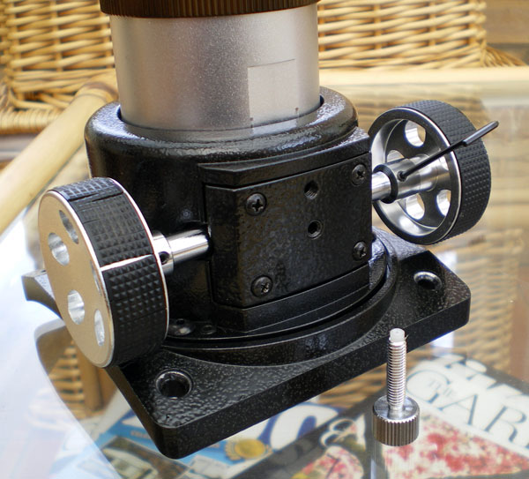](http://www.orion-xt10.com/images/LPC-AF-OldFit-1.jpg)[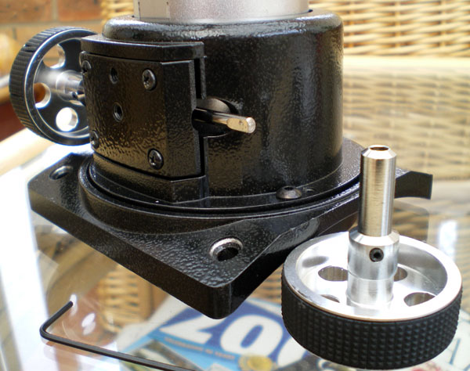](http://www.orion-xt10.com/images/LPC-AF-OldFit-2.jpg)Undo and completely remove the chromed Crayford lock-nut thumbscrew from the focuser.

Next remove the right-hand focus wheel using the hex-key to undo the spindle stub tightening bolt.

Remove the focus wheel from the spindle.

Note the keyed spindle on the original Crayford in this photo (not found on the new Crayford!).

Now, while applying pressure to keep the crayford faceplate in place to prevent it from falling off, undo the four cross-head retaining screws. The bracket will go over the top of the faceplate, but the same screws are used to mount it, so you have to carefully slide the mounting bracket into place after removing the four screws without letting the faceplate come away from the focuser body.

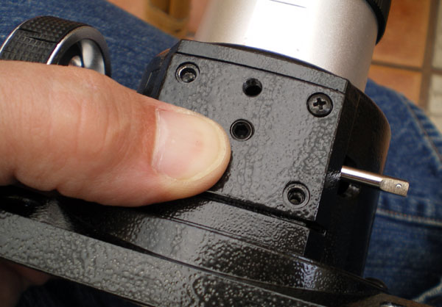

Also note that when the four screws are removed, there is no tension on the focuser drawtube, and it could rotate within the focuser body tube. You just need to ensure the drawtube is aligned correctly with its flat registration feature adjacent to the central holes on the faceplate as you tighten up the mounting screws to hold the bracket in place. Once the bracket is fitted, check that the focuser drawtube operates smoothly and does not bind anywhere. If it does simply undo the screws slightly, rotate the tube to re-align, then re-tighten.

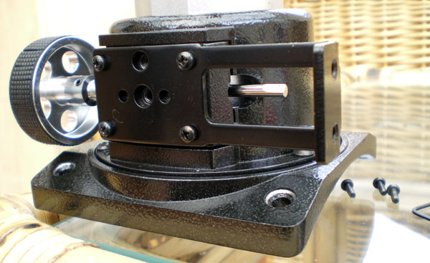

Replace the thumbscrew lock-nut in the upper central hole.

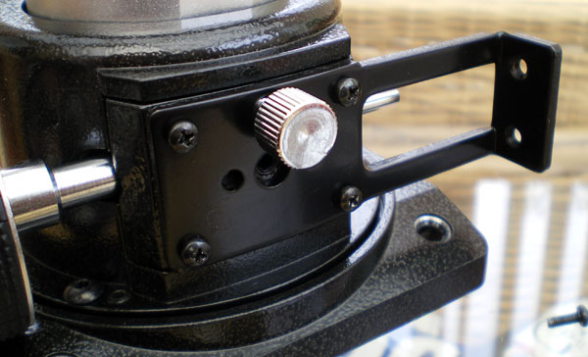

Now push the motor spindle over the focuser spindle, making sure the screw-stub will tighten onto the flattened part of the spindle (do not fully tighten yet), and use the supplied bolts and washers to attach the motor body to the bracket, checking for correct squareness and alignment with the focuser body as the screws are done up.

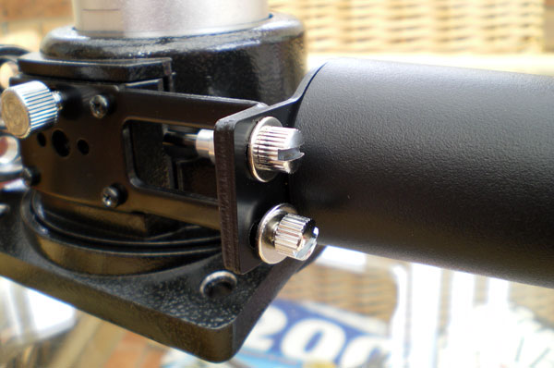

Now tighten the spindle screw-stub.

[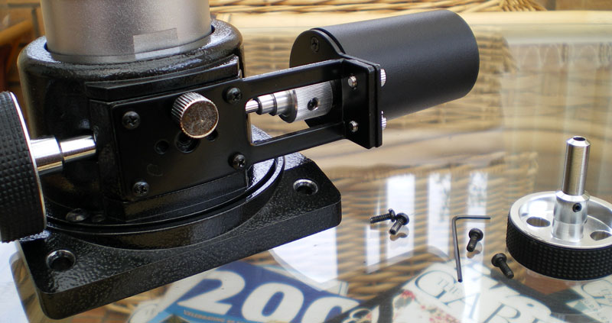](http://www.orion-xt10.com/images/LPC-AF-OldFit-7.jpg)

And here is the fully assembled unit on the standard focuser.

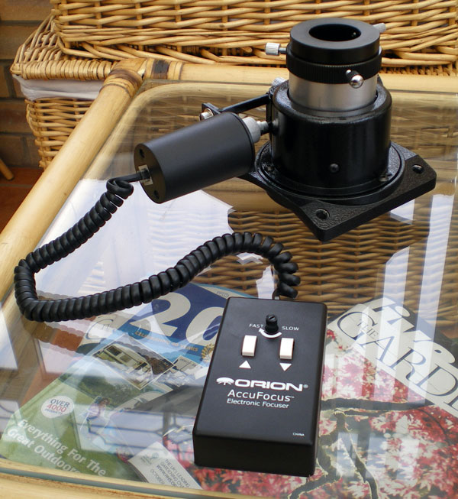

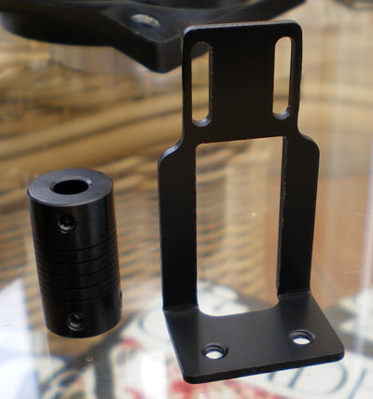The **AccuFocus** can also be mounted onto the even older **Orion Rack and Pinion Focusers**, using the bracket and spindle exte